1. Data Extraction
   1. Created a DataLakeHouse – Merilytics Assessment
   2. Tried creating connections but getting the bad data error to copy the files using Copy activity

Loaded the files directly in a newly created Assessment Data Folder and created subfolder for each source

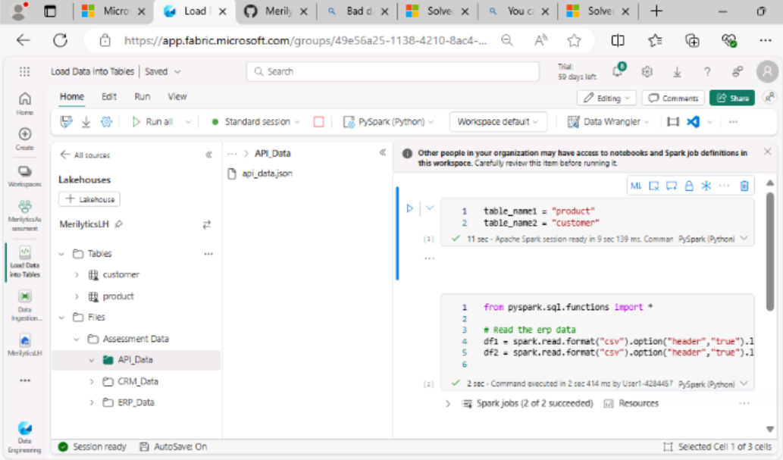

1. Data Transformation
   1. Created a Notebook **Load into Tables** to load the data into Tables

Ran the notebooks to create two tables and loading json file is throwing some exception error.

1. Created and ran the copy activity to create the Location Table using API Data

1. Data Loading
   1. Created a demo pipeline as below

Did not run the pipeline due to bad data error shown in the connection and unable to find the option to ignore bad data to copy files